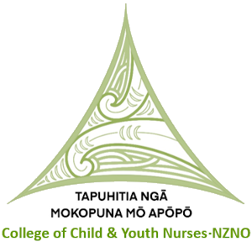


NOMINATION FORM
COLLEGE OF CHILD & YOUTH NURSES (CCYN), TAPUHITIA NGĀ MOKOPUNA MŌ APŌPŌ
(NZNO) COMMITTEE
Nominator to complete
(Please print clearly)
I, _____________________________________________________________ wish to nominate
____________________________________________________________________________
(Surname) (Given Name)
for the position of Committee member on the CCYN Committee.

Signed: ______________________________ Date: ____________________________

Nominee to complete
I, ______________________________________________________ accept the nomination as
National Executive Committee member of the CCYN.
Personal Address: ______________________________________________________________
_____________________________________________________________________________
_______________________________________________________________________________
Ph/ Mobile: ______________________________________________________________________
E-mail:___________________________________________________________________________
Area of current work: ____________________________________________________________
NZNO Membership No. __________________________________________________________
Length of time as a member of the CCYN: ___________________________________________
Work experience, include level of responsibility: _______________________________________
_____________________________________________________________________________
_____________________________________________________________________________
Explain briefly why you think you are suitable for this position (if relevant, include previous committee experience) _____________________________________________________________________
_____________________________________________________________________________
_____________________________________________________________________________
Signature ____________________________ Date: ________________________________
Please attach a recent close-up or passport size photo
To be valid, the completed Nomination Form must be signed by both parties, who are current CCYN members, and received by 5 pm on Monday, 26 October 2026. Please submit by email to: children@nzno.org.nz, or posted to NZNO, CCYN Nominations, PO Box 2128, Wellington 6140.

